Project Development Phase
Model Performance Test

Date | 28 September 2026
Team ID | 6ab221341
Project Name | Implement Client Scripts & UI Policies (Incident)
Maximum Marks | 4 Marks

Model Performance Testing:
Project team shall fill the following information in model performance testing template.
S.No. | Parameter | Screenshot / Values
- 1 | Client Script Testing | Client Script validates incident input and performs dynamic field actions correctly.  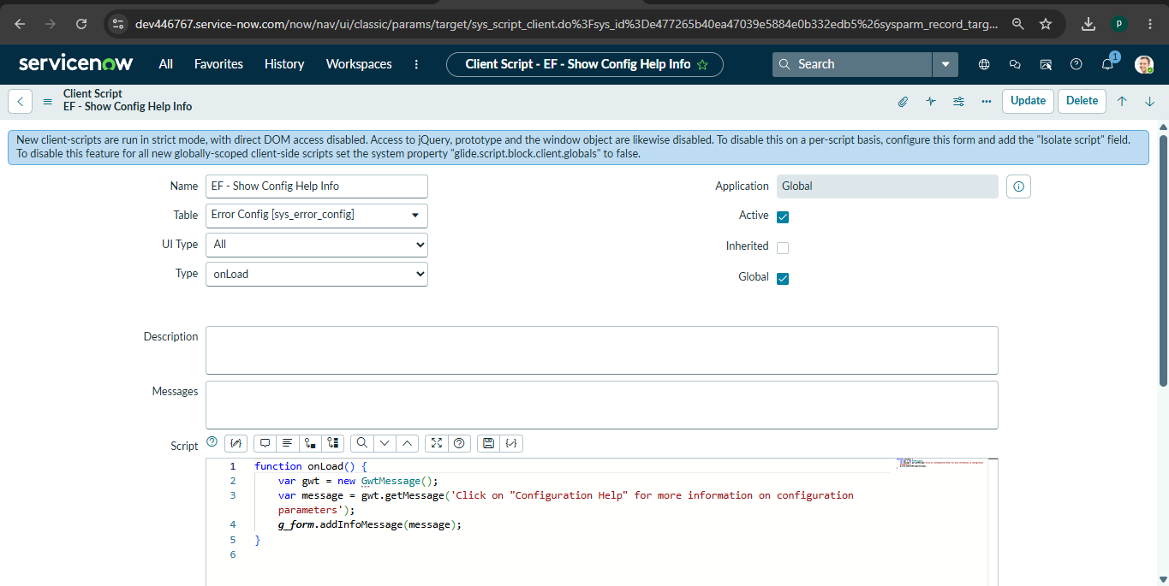
- 2 | UI Policy Testing | UI Policy controls field visibility, mandatory status and read-only behaviour correctly.  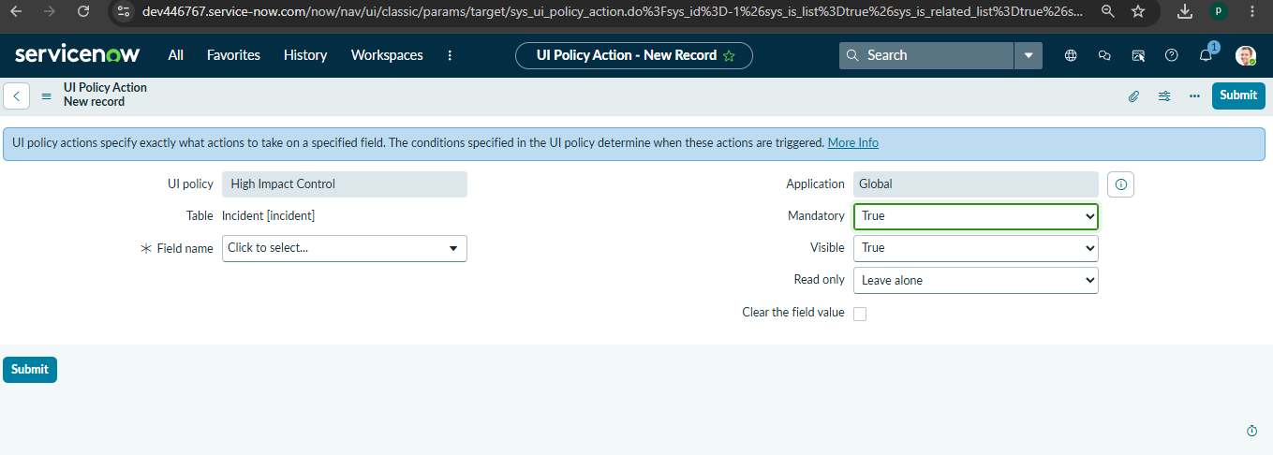
3 | Incident Form Testing | Incident form accepts valid details and saves the incident successfully.  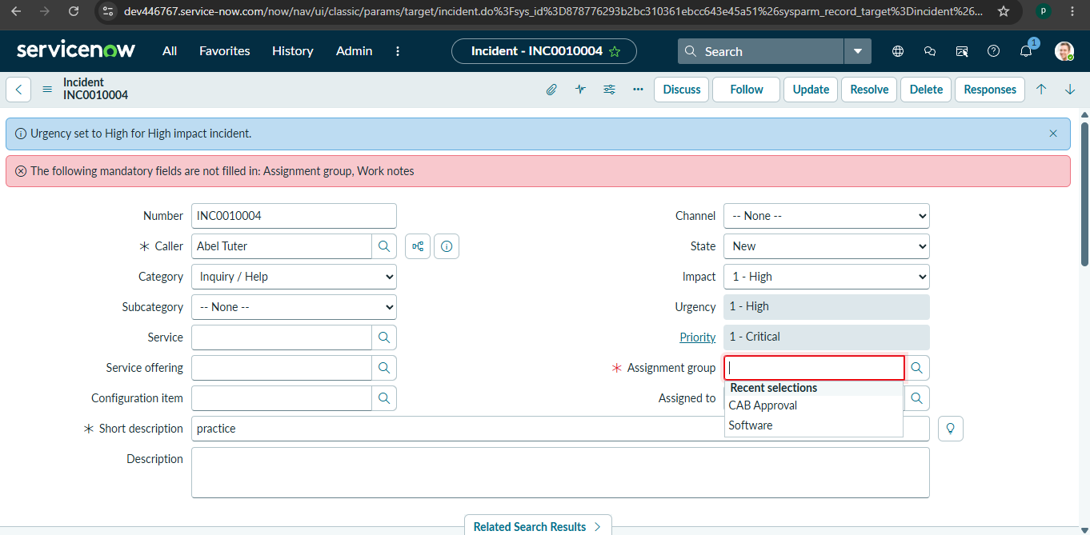
4 | Field Validation Testing | Invalid or incomplete incident details are handled according to the configured Client Script.
5 | Dynamic Field Behaviour | Incident fields change dynamically based on configured Client Scripts and UI Policies.
6 | Incident Submission Testing | Validated incident information is submitted and stored successfully in the ServiceNow Incident Table.  